Lab No | 9,10
Name | Noor Fatima
Reg No | 23_NTU_CS_1083
Semester | BSCS(6thA)
Subject | Web Development
Submitted to | Sir Abdul Basit
Submission Date | 14_04_2026


Computer Science
National Textile University Faisalabad

Lab NO 9|10
Lab 9:
Question. No.1
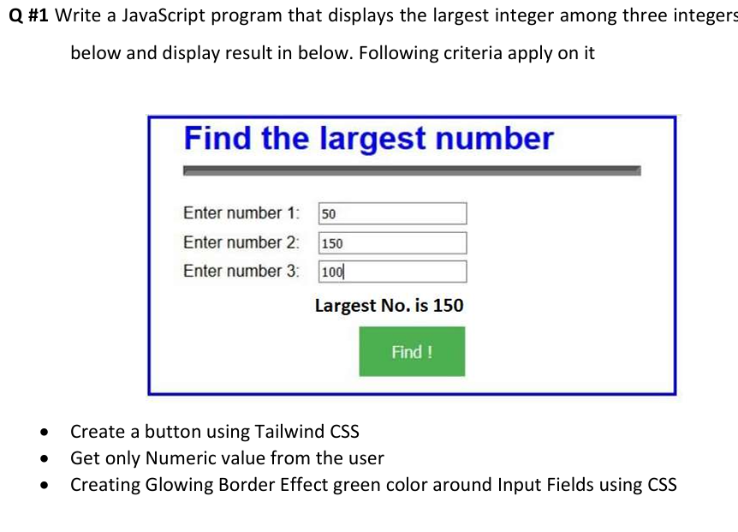
Code:
<!DOCTYPE html>
<html lang="en">
<head>
<meta charset="UTF-8" />
<title>Find the Largest Number</title>
<script src="https://cdn.tailwindcss.com"></script>
<style>
/* Focus style for input fields */
.glow-input:focus {
outline: 2px solid #1010d8 !important;
border-color: #1010d8;
box-shadow: 0 0 0 3px rgba(16, 16, 216, 0.3), 0 0 12px rgba(16, 16, 216, 0.4);
}
</style>
</head>
<body class="bg-gray-100 flex items-center justify-center min-h-screen">
<!-- Container similar to the example -->
<div class="border-4 border-blue-700 rounded-lg p-8 w-full max-w-md bg-white shadow-lg">
<h2 class="text-3xl font-bold text-center mb-6 text-blue-700">Find the largest number</h2>
<hr class="mb-6 border-gray-300" />

<div class="mb-4">
<label class="block mb-1 font-semibold">Enter number 1:</label>
<input
id="n1"
type="text"
placeholder="Enter only Numeric Value"
class="glow-input w-full border-2 border-gray-300 rounded px-3 py-2 text-lg"
/>
</div>

<div class="mb-4">
<label class="block mb-1 font-semibold">Enter number 2:</label>
<input
id="n2"
type="text"
placeholder="Enter only Numeric Value"
class="glow-input w-full border-2 border-gray-300 rounded px-3 py-2 text-lg"
/>
</div>

<div class="mb-4">
<label class="block mb-1 font-semibold">Enter number 3:</label>
<input
id="n3"
type="text"
placeholder="Enter only Numeric Value"
class="glow-input w-full border-2 border-gray-300 rounded px-3 py-2 text-lg"
/>
</div>

<div id="result" class="mt-4 text-center font-bold text-xl hidden"></div>

<button
onclick="findLargest()"
class="w-full bg-green-600 hover:bg-green-700 text-white font-semibold py-3 rounded-lg mt-6 text-lg"
>
Find !
</button>
</div>

<script>
function findLargest() {
var a = document.getElementById('n1').value.trim();
var b = document.getElementById('n2').value.trim();
var c = document.getElementById('n3').value.trim();

if (a === '' || b === '' || c === '') {
alert('Please fill all fields!');
return;
}
if (isNaN(a) || isNaN(b) || isNaN(c)) {
alert('Enter numeric values only!');
return;
}

a = parseFloat(a);
b = parseFloat(b);
c = parseFloat(c);
var largest = Math.max(a, b, c);

var result = document.getElementById('result');
result.textContent = 'Largest Number is: ' + largest;
result.classList.remove('hidden');
}
</script>
</body>
</html>
Output:
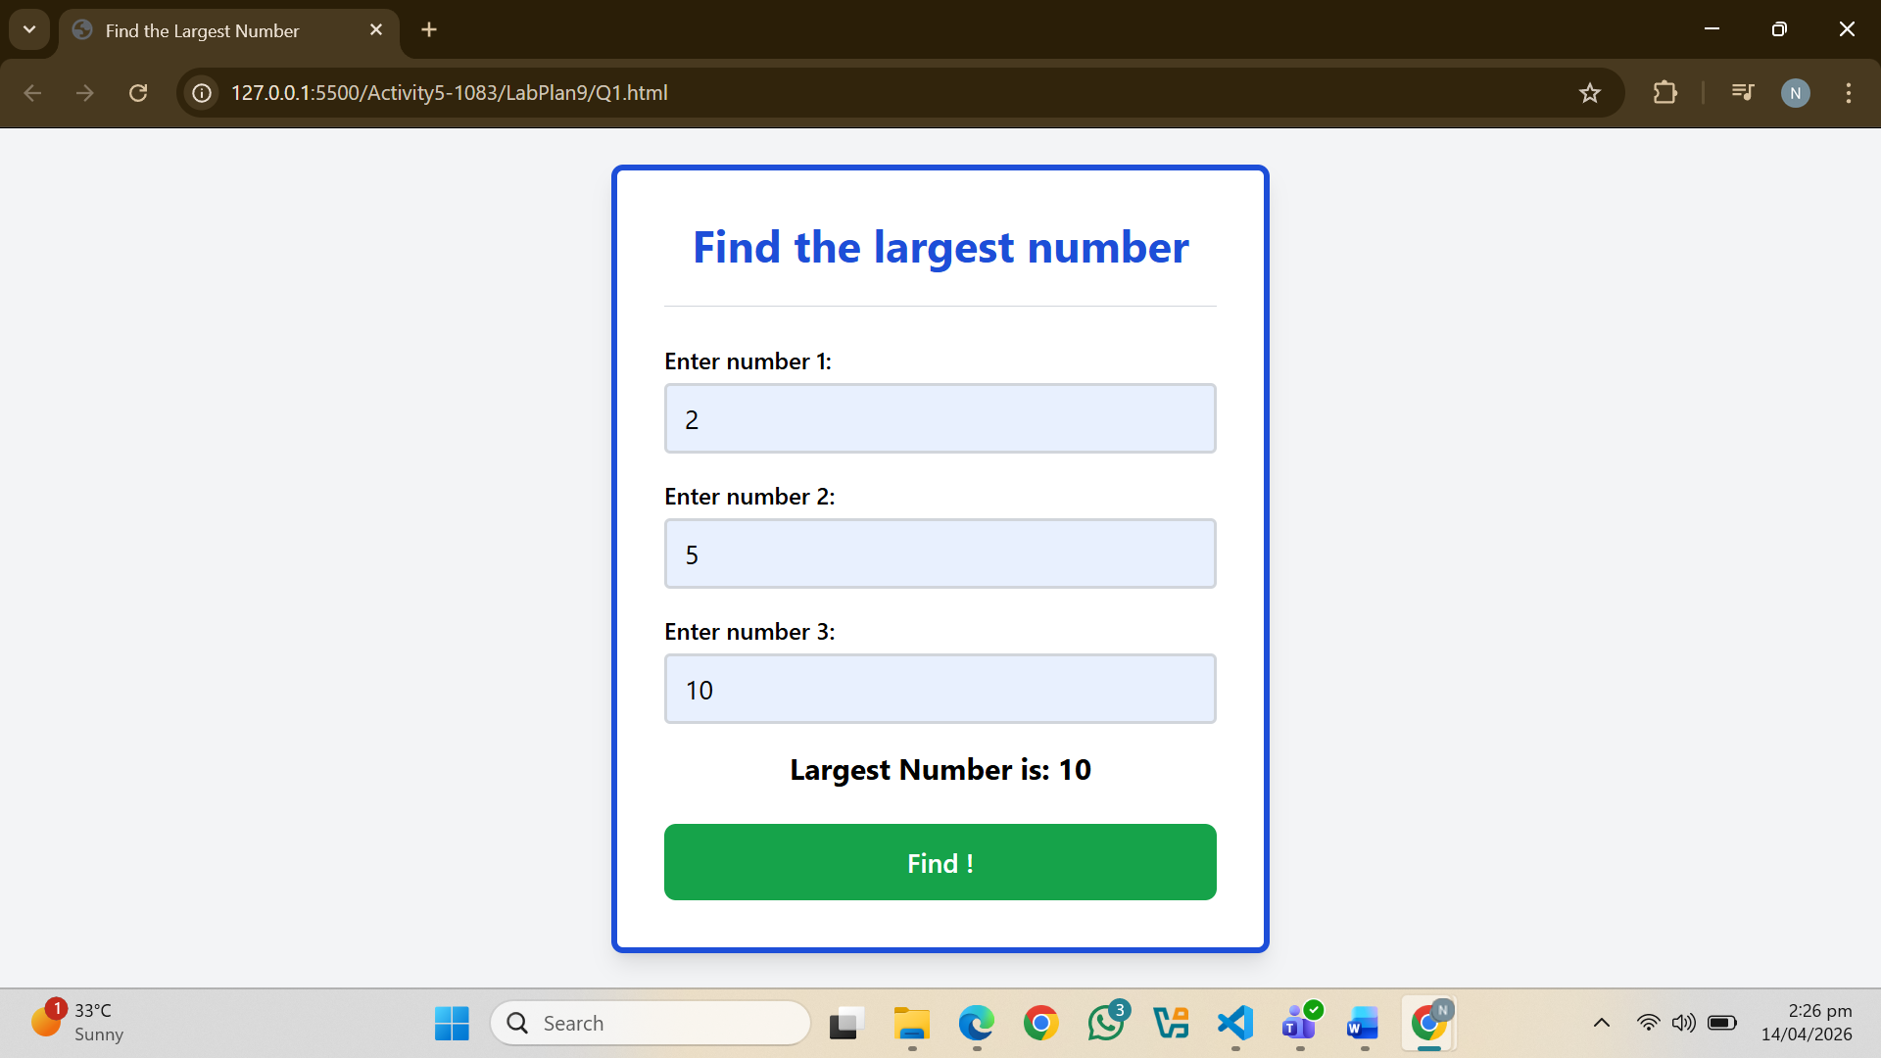
Question. No.2
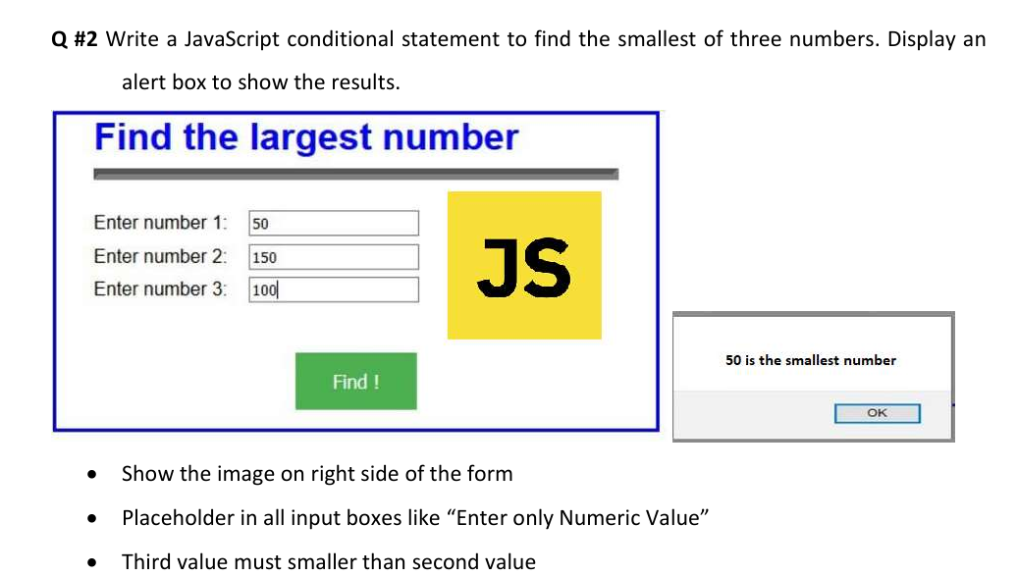
Code:
<!DOCTYPE html>
<html lang="en">
<head>
<meta charset="UTF-8">
<title>Find the Smallest Number</title>
<style>
body {
font-family: Arial, sans-serif;
background: #f0f0f0;
display: flex;
justify-content: center;
align-items: center;
min-height: 100vh;
margin: 0;
}

.wrapper {
display: flex;
align-items: flex-start;
gap: 30px;
}

.form-box {
border: 3px solid #1a3cbe;
background: white;
padding: 30px 30px 30px 30px;
width: 420px;
position: relative;
}

h2 {
color: #1a3cbe;
font-size: 22px;
margin: 0 0 15px 0;
}

hr {
border: none;
border-top: 3px solid #aaa;
margin-bottom: 20px;
}

.form-inner {
display: flex;
align-items: center;
gap: 20px;
}

.fields {
flex: 1;
}

.field-row {
display: flex;
align-items: center;
margin-bottom: 14px;
}

.field-row label {
width: 130px;
font-size: 14px;
}

.field-row input {
width: 160px;
padding: 5px 8px;
border: 1px solid #ccc;
font-size: 14px;
}

.js-logo {
background: #f0c800;
color: black;
font-size: 48px;
font-weight: bold;
width: 100px;
height: 100px;
display: flex;
align-items: center;
justify-content: center;
flex-shrink: 0;
}

.btn-find {
background: #3cb043;
color: white;
border: none;
padding: 10px 30px;
font-size: 15px;
cursor: pointer;
margin-top: 10px;
margin-left: 130px;
}

.btn-find:hover {
background: #2d8a34;
}

/* Alert box on the right */
.alert-box {
background: white;
border: 1px solid #aaa;
box-shadow: 3px 3px 8px rgba(0,0,0,0.25);
padding: 20px 24px;
width: 200px;
text-align: center;
}

.alert-box.hidden {
visibility: hidden;
}

.alert-box p {
font-size: 14px;
font-weight: bold;
margin: 0 0 16px 0;
}

.alert-box button {
border: 1px solid #aaa;
background: white;
padding: 4px 20px;
cursor: pointer;
font-size: 13px;
}

.alert-box button:hover {
background: #e0e0e0;
}
</style>
</head>
<body>

<div class="wrapper">

<!-- Form -->
<div class="form-box">
<h2>Find the smallest number</h2>
<hr>
<div class="form-inner">
<div class="fields">
<div class="field-row">
<label>Enter number 1:</label>
<input type="number" id="num1" placeholder="Enter only Numeric Value">
</div>
<div class="field-row">
<label>Enter number 2:</label>
<input type="number" id="num2" placeholder="Enter only Numeric Value">
</div>
<div class="field-row">
<label>Enter number 3:</label>
<input type="number" id="num3" placeholder="Enter only Numeric Value">
</div>
</div>
<div class="js-logo">JS</div>
</div>
<button class="btn-find" onclick="findSmallest()">Find !</button>
</div>

<!-- Alert Box on the RIGHT -->
<div class="alert-box hidden" id="alertBox">
<p id="alertMessage"></p>
<button onclick="closeAlert()">OK</button>
</div>

</div>

<script>
function findSmallest() {
const n1 = parseFloat(document.getElementById('num1').value);
const n2 = parseFloat(document.getElementById('num2').value);
const n3 = parseFloat(document.getElementById('num3').value);

if (isNaN(n1) || isNaN(n2) || isNaN(n3)) {
showAlert("Please enter valid numeric values in all fields.");
return;
}

if (n3 >= n2) {
showAlert("Third value must be smaller than second value.");
return;
}

let smallest;
if (n1 <= n2 && n1 <= n3) {
smallest = n1;
} else if (n2 <= n1 && n2 <= n3) {
smallest = n2;
} else {
smallest = n3;
}

showAlert(smallest + " is the smallest number");
}
function showAlert(message) {
document.getElementById('alertMessage').textContent = message;
document.getElementById('alertBox').classList.remove('hidden');
}
function closeAlert() {
document.getElementById('alertBox').classList.add('hidden');
}
</script>
</body>
</html>
Output:
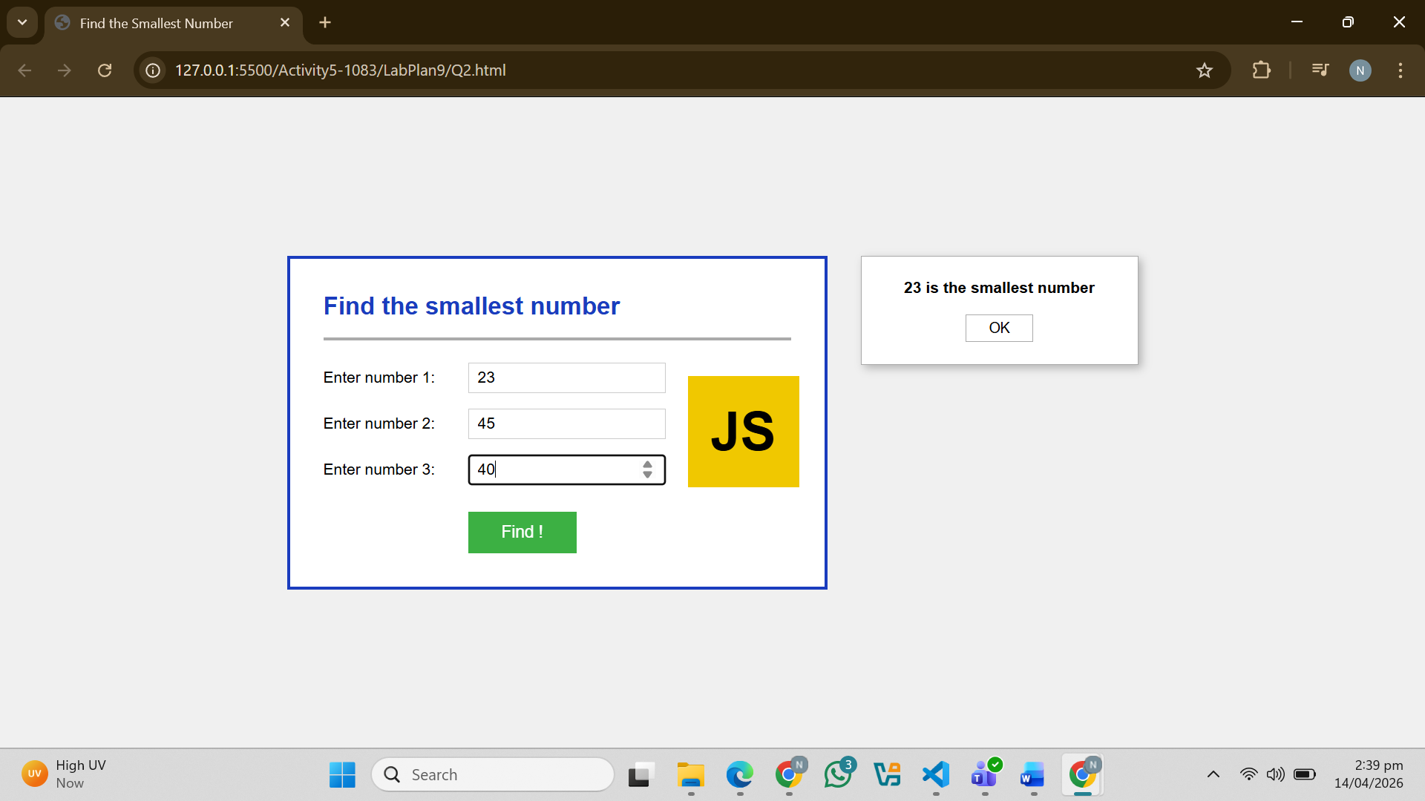
Question. No.3
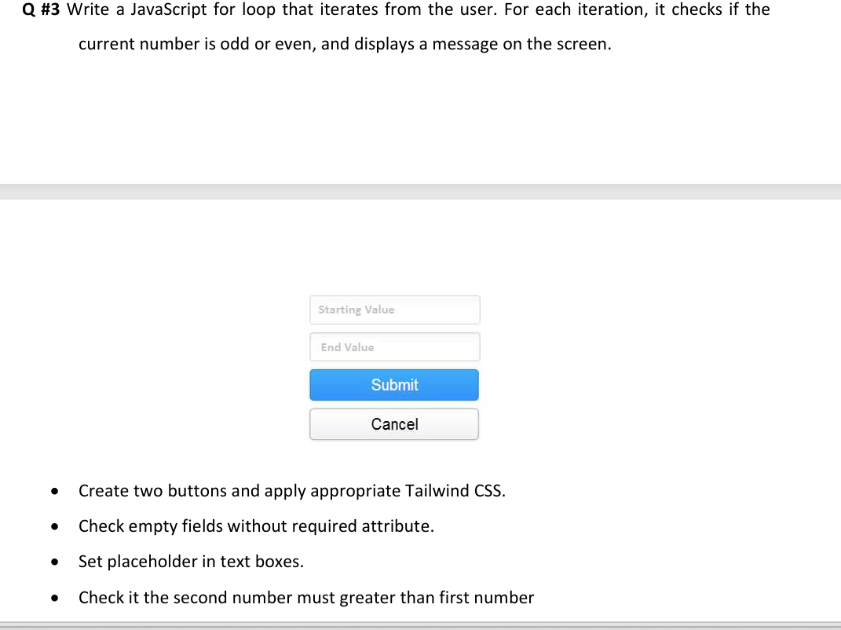
Code:
<!DOCTYPE html>
<html lang="en">
<head>
<meta charset="UTF-8">
<title>Q3 - Odd or Even</title>
<script src="https://cdn.tailwindcss.com"></script>
<style>
.glow-input:focus {
outline: none;
border-color: #22c55e;
box-shadow: 0 0 0 3px rgba(34,197,94,0.3), 0 0 12px rgba(34,197,94,0.4);
}
</style>
</head>
<body class="bg-gray-100 flex items-center justify-center min-h-screen">
<div class="bg-white p-8 rounded-xl shadow-md w-96">
<label class="block mb-1 font-medium">Starting Number</label>
<input id="n1" type="text" placeholder="Enter only Numeric Value"
class="glow-input w-full border-2 border-gray-300 rounded-lg px-4 py-2 mb-4">

<label class="block mb-1 font-medium">Ending Number <span class="text-sm text-red-400">(must be greater than start)</span></label>
<input id="n2" type="text" placeholder="Enter only Numeric Value"
class="glow-input w-full border-2 border-gray-300 rounded-lg px-4 py-2 mb-6">

<div class="flex flex-col space-y-4">
<button onclick="checkOddEven()"
class="bg-indigo-600 hover:bg-indigo-700 text-white font-semibold py-2 rounded-lg">
Check
</button>
<button onclick="resetForm()"
class="bg-gray-400 hover:bg-gray-500 text-white font-semibold py-2 rounded-lg">
Cancel
</button>
</div>

<div id="result" class="mt-6 max-h-60 overflow-y-auto hidden"></div>
</div>

<script>
function checkOddEven() {
var a = document.getElementById('n1').value.trim();
var b = document.getElementById('n2').value.trim();

if (a === '' || b === '') {
alert('Please fill all fields!');
return;
}
if (isNaN(a) || isNaN(b)) {
alert('Enter numeric values only!');
return;
}

a = parseInt(a); b = parseInt(b);

if (b <= a) {
alert('End number must be greater than start number!');
return;
}

var html = '';
for (var i = a; i <= b; i++) {
if (i % 2 === 0) {
html += '<p class="text-blue-600 font-medium">' + i + ' is Even</p>';
} else {
html += '<p class="text-pink-600 font-medium">' + i + ' is Odd</p>';
}
}

var result = document.getElementById('result');
result.innerHTML = html;
result.classList.remove('hidden');
}

function resetForm() {
document.getElementById('n1').value = '';
document.getElementById('n2').value = '';
var result = document.getElementById('result');
result.innerHTML = '';
result.classList.add('hidden');
}
</script>
</body>
</html>
Output:
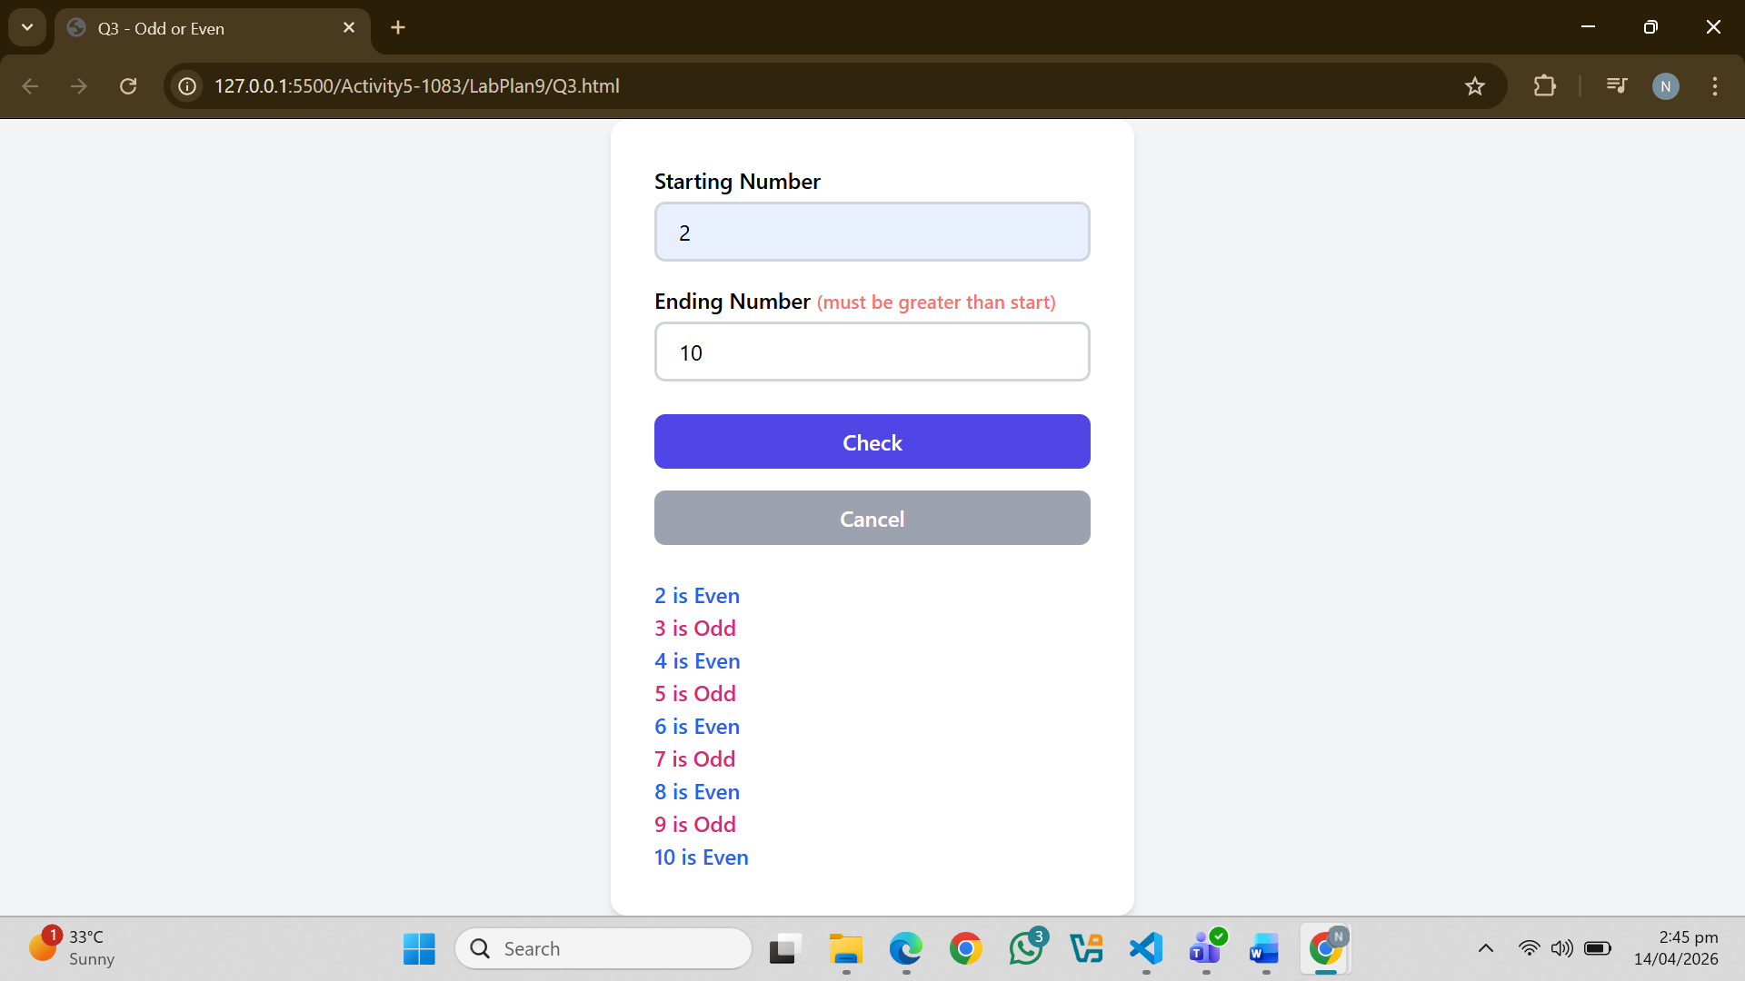
Question. No.4
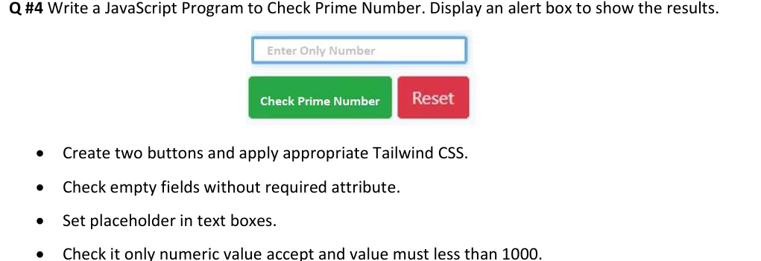
Code:
<!DOCTYPE html>
<html lang="en">
<head>
<meta charset="UTF-8">
<title>Q4 - Prime Number</title>
<script src="https://cdn.tailwindcss.com"></script>
<style>
.glow-input:focus {
outline: none;
border-color: #22c55e;
box-shadow: 0 0 0 3px rgba(34,197,94,0.3), 0 0 12px rgba(34,197,94,0.4);
}
</style>
</head>
<body class="bg-gray-100 flex items-center justify-center min-h-screen">
<div class="bg-white p-8 rounded-xl shadow-md w-96">
<label class="block mb-1 font-medium">Enter a Number <span class="text-sm text-red-400">(less than 1000)</span></label>
<input id="n1" type="text" placeholder="Enter only Numeric Value"
class="glow-input w-full border-2 border-gray-300 rounded-lg px-4 py-2 mb-6">

<div class="flex gap-4">
<button onclick="checkPrime()"
class="flex-1 bg-green-600 hover:bg-green-700 text-white font-semibold py-2 rounded-lg">
Check Prime
</button>
<button onclick="resetForm()"
class="flex-1 bg-red-400 hover:bg-red-500 text-white font-semibold py-2 rounded-lg">
Reset
</button>
</div>
</div>

<script>
function checkPrime() {
var a = document.getElementById('n1').value.trim();

if (a === '') {
alert('Please enter a number!');
return;
}
if (isNaN(a) || a.includes('.')) {
alert('Enter numeric values only (no decimals)!');
return;
}

a = parseInt(a);

if (a >= 1000 || a < 2) {
alert('Value must be between 2 and 999!');
return;
}

var prime = true;
for (var i = 2; i <= Math.sqrt(a); i++) {
if (a % i === 0) {
prime = false;
break;
}
}

if (prime) {
alert(a + ' is a PRIME number!');
} else {
alert(a + ' is NOT a prime number!');
}
}

function resetForm() {
document.getElementById('n1').value = '';
}
</script>
</body>
</html>
Output:
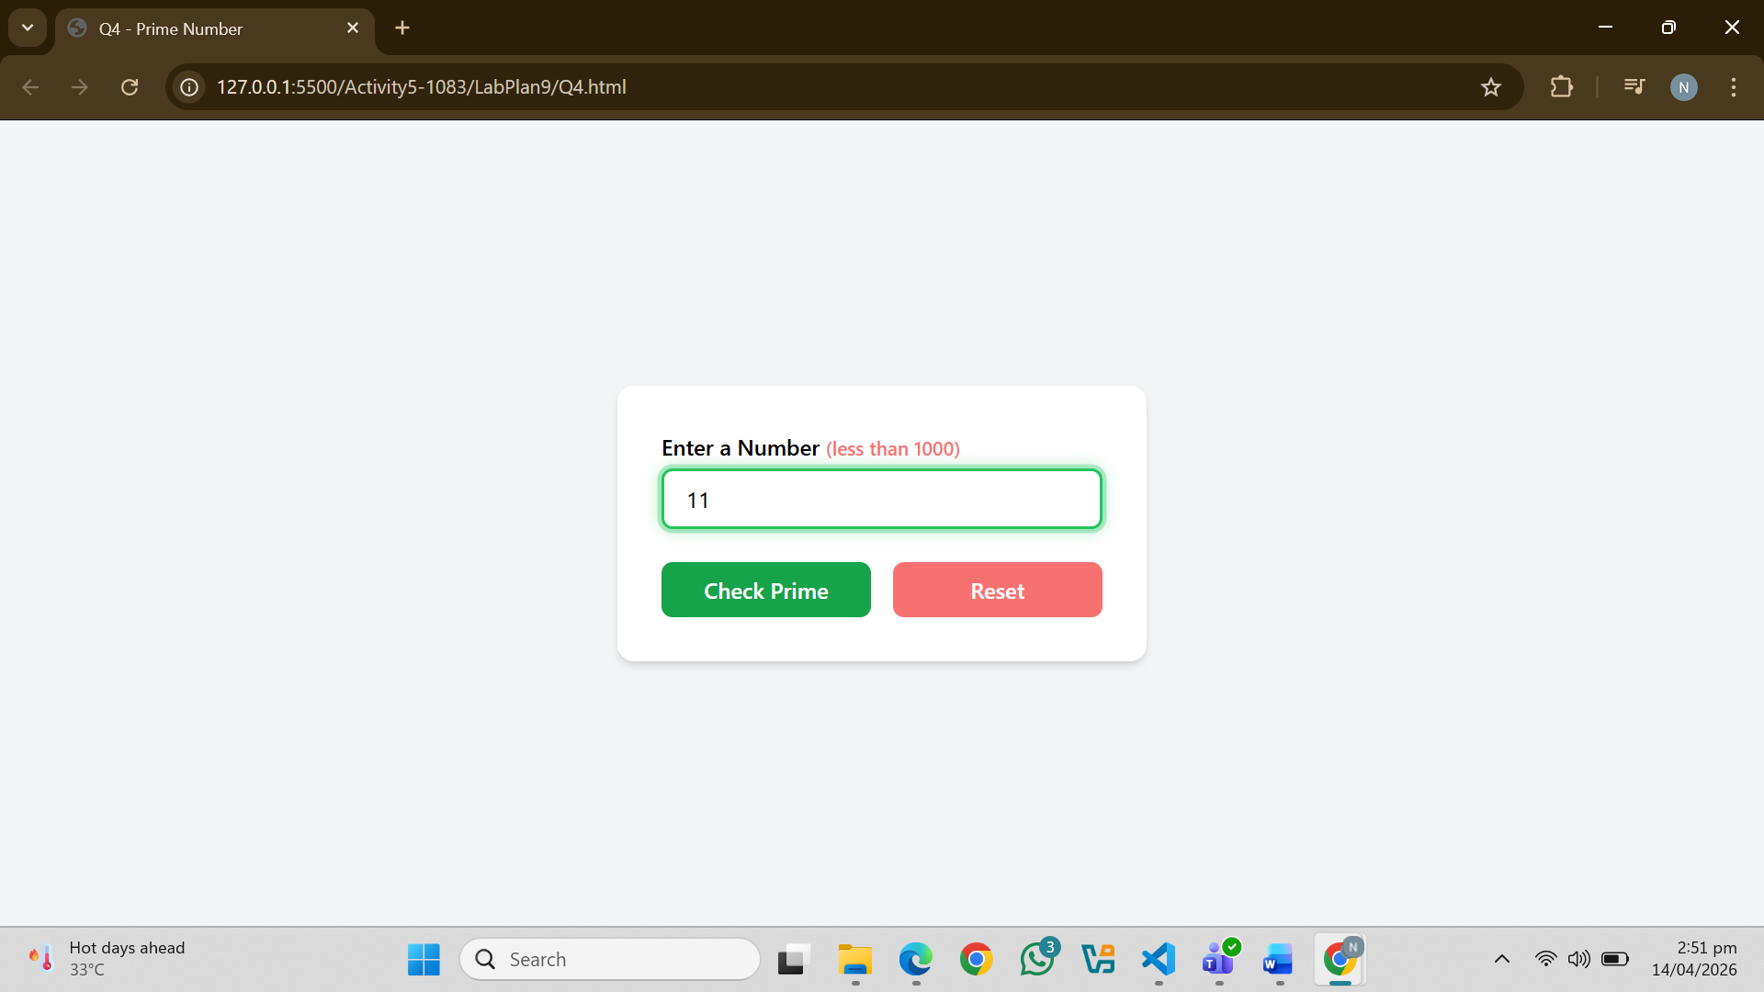
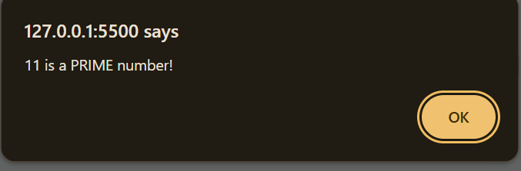
Question. No.5
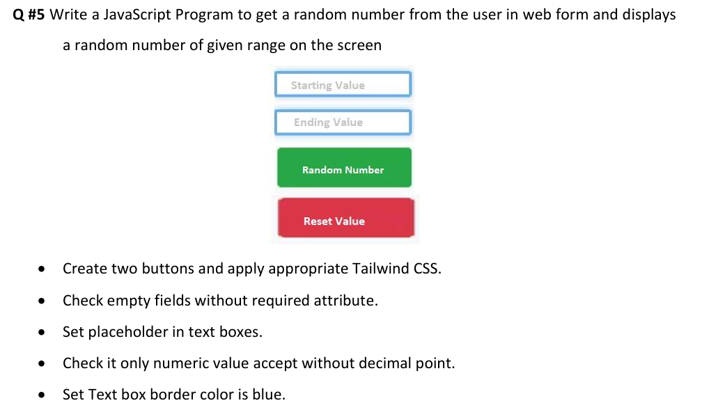
Code:
<!DOCTYPE html>
<html lang="en">
<head>
<meta charset="UTF-8">
<title>Q5 - Random Number</title>
<script src="https://cdn.tailwindcss.com"></script>
</head>
<body class="bg-gray-100 flex items-center justify-center min-h-screen">
<div class="bg-white p-8 rounded-xl shadow-md w-96">
<label class="block mb-1 font-medium">Starting Value</label>
<input id="n1" type="text" placeholder="Enter only Numeric Value"
class="w-full border-2 border-blue-500 focus:border-blue-700 focus:outline-none rounded-lg px-4 py-2 mb-4">

<label class="block mb-1 font-medium">Ending Value</label>
<input id="n2" type="text" placeholder="Enter only Numeric Value"
class="w-full border-2 border-blue-500 focus:border-blue-700 focus:outline-none rounded-lg px-4 py-2 mb-6">

<div class="flex flex-col space-y-4">
<button onclick="generateRandom()"
class="bg-green-600 hover:bg-green-700 text-white font-semibold py-2 rounded-lg">
Generate
</button>
<button onclick="resetForm()"
class="bg-red-400 hover:bg-red-500 text-white font-semibold py-2 rounded-lg">
Reset
</button>
</div>

<div id="result" class="mt-6 text-center text-2xl font-bold text-green-600 hidden"></div>
</div>

<script>
function generateRandom() {
var a = document.getElementById('n1').value.trim();
var b = document.getElementById('n2').value.trim();

if (a === '' || b === '') {
alert('Please fill all fields!');
return;
}
if (isNaN(a) || isNaN(b) || a.includes('.') || b.includes('.')) {
alert('Enter integers only (no decimal points)!');
return;
}

a = parseInt(a); b = parseInt(b);

if (b <= a) {
alert('Maximum must be greater than minimum!');
return;
}

var rand = Math.floor(Math.random() * (b - a + 1)) + a;

var result = document.getElementById('result');
result.textContent = 'Random Number: ' + rand;
result.classList.remove('hidden');
}
function resetForm() {
document.getElementById('n1').value = '';
document.getElementById('n2').value = '';
var result = document.getElementById('result');
result.textContent = '';
result.classList.add('hidden');
}
</script>
</body>
</html>
Output:
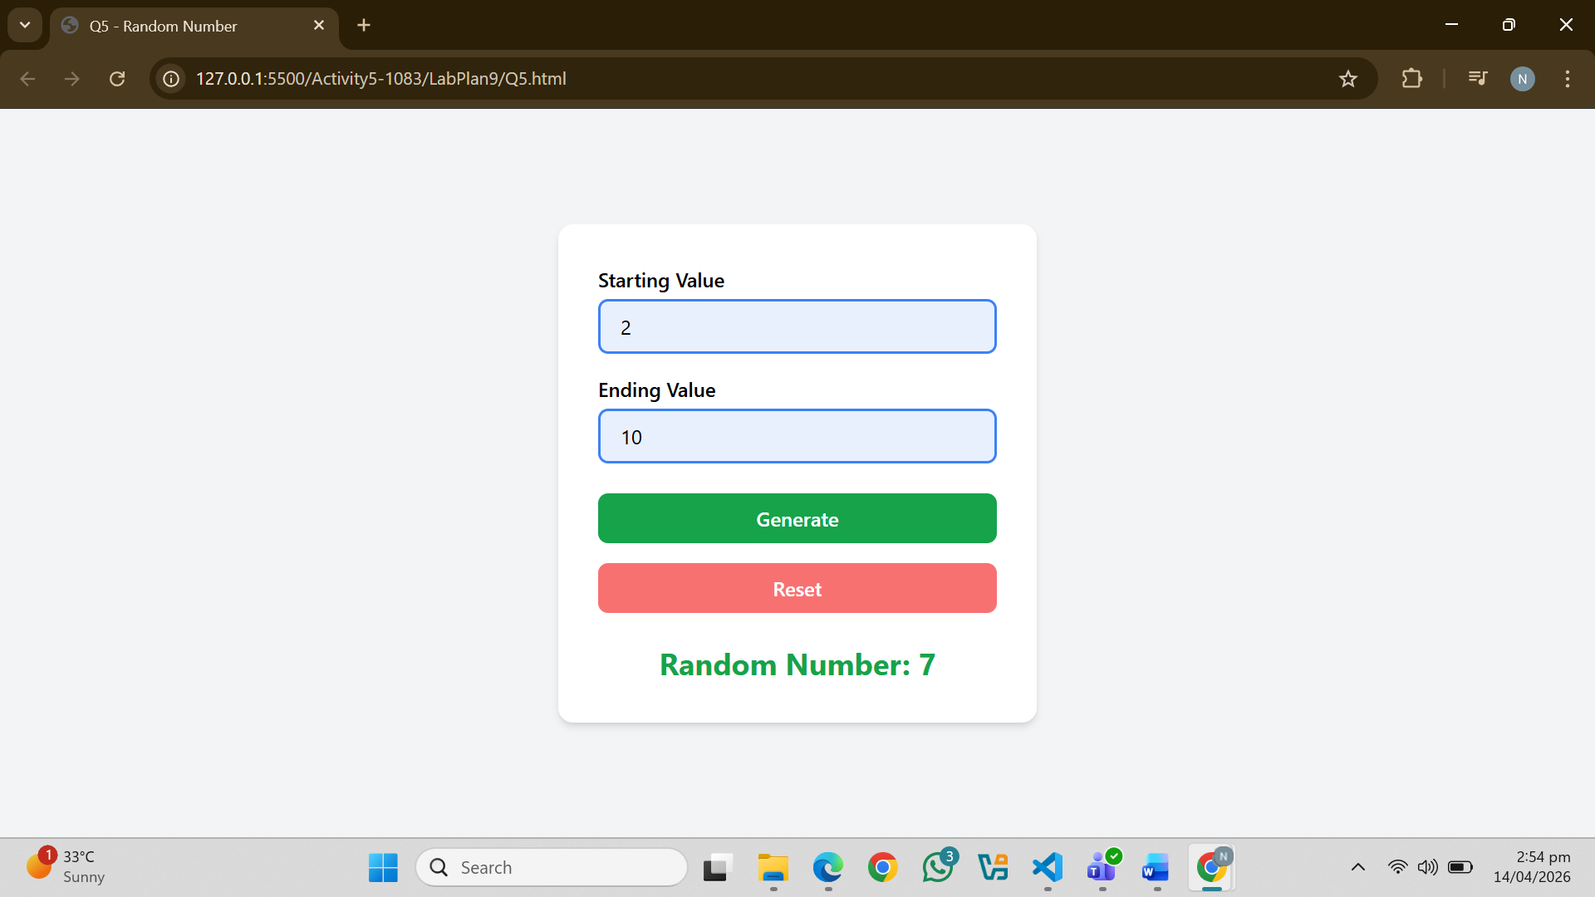
****************************************************
Lab 10:
Question. No.1
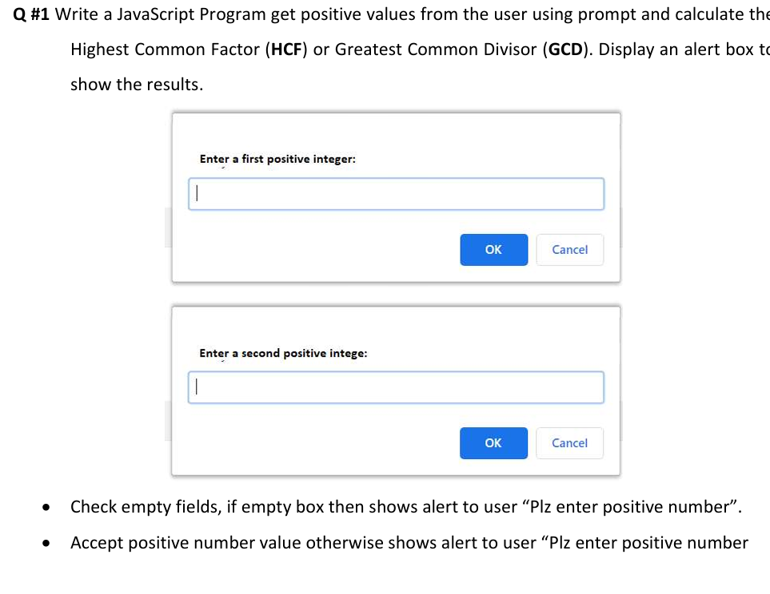
Code:
<!DOCTYPE html>
<html lang="en">
<head>
<meta charset="UTF-8" />
<title>GCD Calculator</title>
<script src="https://cdn.tailwindcss.com"></script>
</head>
<body class="bg-gray-100 flex items-center justify-center min-h-screen">
<div class="bg-white p-8 rounded-xl shadow-md w-96">
<h2 class="text-2xl font-semibold mb-4 text-center">GCD Calculator</h2>

<label class="block mb-1 font-medium" for="n1">First Positive Integer</label>
<input
id="n1"
type="text"
placeholder="Enter first positive number"
class="w-full border-2 border-blue-500 focus:border-blue-700 focus:outline-none rounded-lg px-4 py-2 mb-4"
/>

<label class="block mb-1 font-medium" for="n2">Second Positive Integer</label>
<input
id="n2"
type="text"
placeholder="Enter second positive number"
class="w-full border-2 border-blue-500 focus:border-blue-700 focus:outline-none rounded-lg px-4 py-2 mb-6"
/>

<div class="flex flex-col space-y-4 mb-4">
<button
onclick="calculateGCD()"
class="bg-green-600 hover:bg-green-700 text-white font-semibold py-2 rounded-lg"
>
Calculate GCD
</button>
<button
onclick="resetForm()"
class="bg-red-400 hover:bg-red-500 text-white font-semibold py-2 rounded-lg"
>
Reset
</button>
</div>

<div id="result" class="mt-4 text-center text-2xl font-bold text-green-600 hidden"></div>
</div>

<script>
function getPositiveInteger(id) {
const value = document.getElementById(id).value.trim();
if (value === '') {
alert('Please enter a number!');
return null;
}
if (!/^\d+$/.test(value)) {
alert('Enter positive number only!');
return null;
}
const num = parseInt(value, 10);
if (num <= 0) {
alert('Number must be positive!');
return null;
}
return num;
}

function calculateGCD() {
const num1 = getPositiveInteger('n1');
const num2 = getPositiveInteger('n2');

if (num1 === null || num2 === null) {
return; // Validation failed
}

// Euclidean Algorithm
let a = num1;
let b = num2;
while (b !== 0) {
const temp = b;
b = a % b;
a = temp;
}

const resultDiv = document.getElementById('result');
resultDiv.textContent = `GCD of ${num1} and ${num2} is ${a}`;
resultDiv.classList.remove('hidden');
}

function resetForm() {
document.getElementById('n1').value = '';
document.getElementById('n2').value = '';
const resultDiv = document.getElementById('result');
resultDiv.textContent = '';
resultDiv.classList.add('hidden');
}
</script>
</body>
</html>
Output:
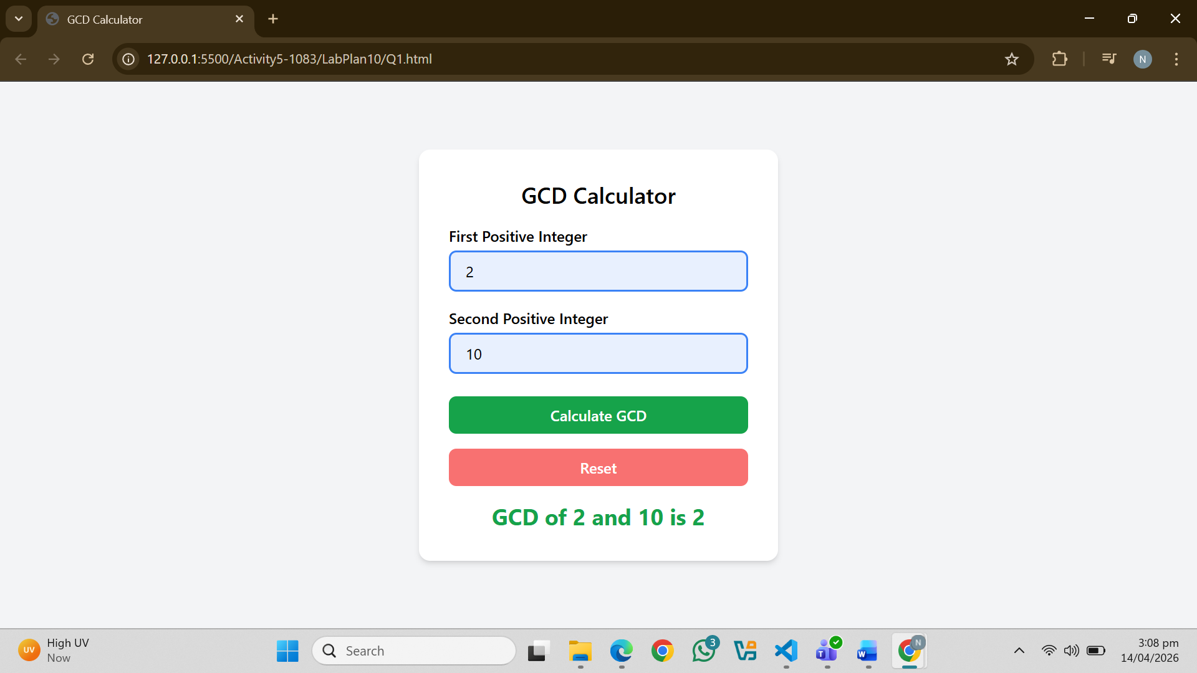
Question. No.2
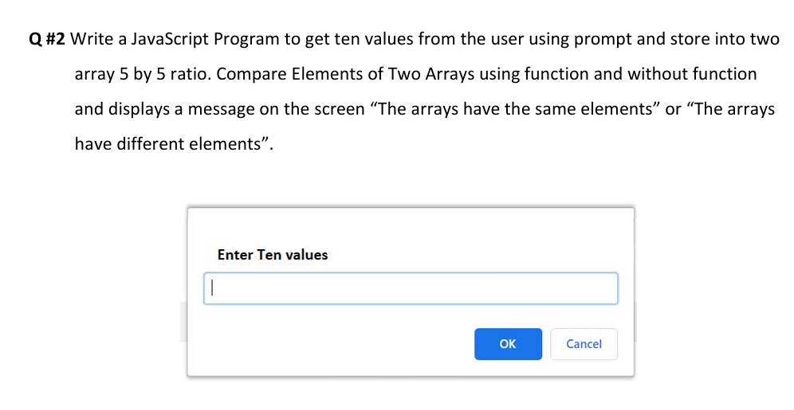
Code:
<!DOCTYPE html>
<html lang="en">
<head>
<meta charset="UTF-8" />
<title>Array Comparison</title>
<script src="https://cdn.tailwindcss.com"></script>
</head>
<body class="bg-gray-100 flex items-center justify-center min-h-screen">
<div class="bg-white p-8 rounded-xl shadow-md w-96">
<h2 class="text-2xl font-semibold mb-4 text-center">Array Comparison</h2>

<button onclick="getAndCompareArrays()"
class="w-full bg-blue-600 hover:bg-blue-700 text-white font-semibold py-2 rounded-lg mb-4">
Enter 10 Values & Compare
</button>

<!-- Shows both array values -->
<div id="arrays" class="text-sm text-gray-600 mb-3"></div>

<!-- WITHOUT FUNCTION result -->
<div class="mb-2">
<span class="font-semibold text-gray-700">Without Function: </span>
<span id="result-without" class="font-medium"></span>
</div>

<!-- WITH FUNCTION result -->
<div>
<span class="font-semibold text-gray-700">With Function: </span>
<span id="result-with" class="font-medium"></span>
</div>
</div>

<script>

// ─── Get 10 values via prompt, split 5 by 5 ───
function getArrays() {
const arr1 = [];
const arr2 = [];

for (let i = 0; i < 10; i++) {
let value;
while (true) {
value = prompt(`Enter value ${i + 1} of 10:`);
if (value === null || value.trim() === '') {
alert('Please enter a value!');
continue;
}
if (!/^-?\d+(\.\d+)?$/.test(value.trim())) {
alert('Enter a valid number!');
continue;
}
break;
}
value = parseFloat(value.trim());
if (i < 5) {
arr1.push(value); // first 5 → array1
} else {
arr2.push(value); // last 5 → array2
}
}
return { arr1, arr2 };
}

// ════════════════════════════════
// METHOD 1: WITH FUNCTION
// ════════════════════════════════
function compareArrays(arr1, arr2) {
for (let i = 0; i < arr1.length; i++) {
if (arr1[i] !== arr2[i]) return false;
}
return true;
}

// ════════════════════════════════
// MAIN: runs both methods
// ════════════════════════════════
function getAndCompareArrays() {
const { arr1, arr2 } = getArrays();

// Show arrays on screen
document.getElementById('arrays').innerHTML =
`<b>Array 1:</b> [${arr1}] <br> <b>Array 2:</b> [${arr2}]`;

// ── WITHOUT FUNCTION ──
let isSame = true;
for (let i = 0; i < 5; i++) {
if (arr1[i] !== arr2[i]) {
isSame = false;
break;
}
}
const withoutResult = document.getElementById('result-without');
if (isSame) {
withoutResult.textContent = 'The arrays have the same elements.';
withoutResult.className = 'font-medium text-green-600';
} else {
withoutResult.textContent = 'The arrays have different elements.';
withoutResult.className = 'font-medium text-red-500';
}

// ── WITH FUNCTION ──
const areEqual = compareArrays(arr1, arr2);
const withResult = document.getElementById('result-with');
if (areEqual) {
withResult.textContent = 'The arrays have the same elements.';
withResult.className = 'font-medium text-green-600';
} else {
withResult.textContent = 'The arrays have different elements.';
withResult.className = 'font-medium text-red-500';
}
}

</script>
</body>
</html>
Output:
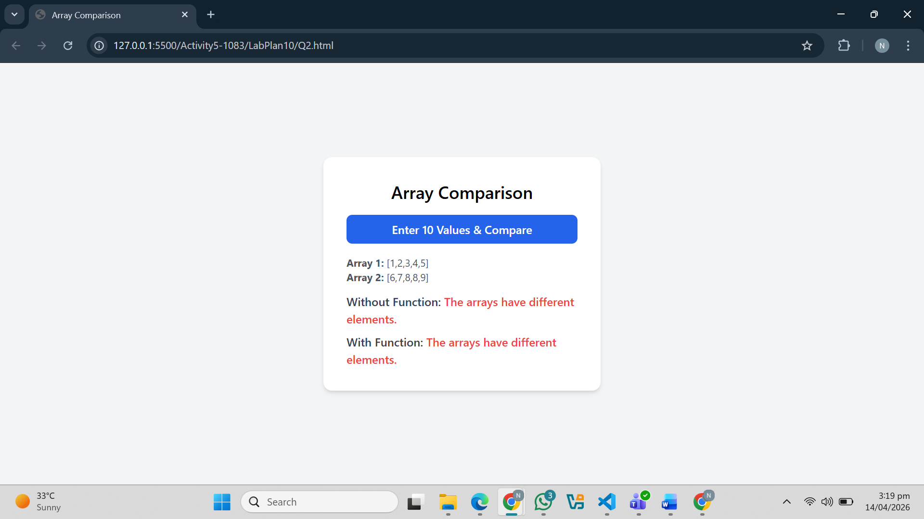
Question. No.3
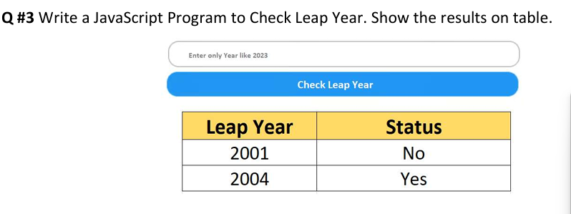
Code:
<!DOCTYPE html>
<html>
<head>
<script src="https://cdn.tailwindcss.com"></script>
</head>

<body class="flex flex-col items-center mt-10">

<input id="year" type="number" placeholder="Enter year like 2024"
class="border p-2 rounded w-64 mb-4">

<button onclick="checkLeap()"
class="bg-blue-500 text-white px-4 py-2 rounded mb-4">
Check Leap Year
</button>

<table class="border border-black text-center">
<thead class="bg-yellow-300">
<tr>
<th class="border px-4">Year</th>
<th class="border px-4">Status</th>
</tr>
</thead>
<tbody id="result"></tbody>
</table>

<script>
function checkLeap() {
let year = document.getElementById("year").value;

if (year === "") {
alert("Enter a year!");
return;
}

let isLeap = (year % 4 == 0 && year % 100 != 0) || (year % 400 == 0);

let status = isLeap ? "Yes" : "No";

document.getElementById("result").innerHTML += `
<tr>
<td class="border px-4">${year}</td>
<td class="border px-4">${status}</td>
</tr>
`;
}
</script>

</body>
</html>
Output:
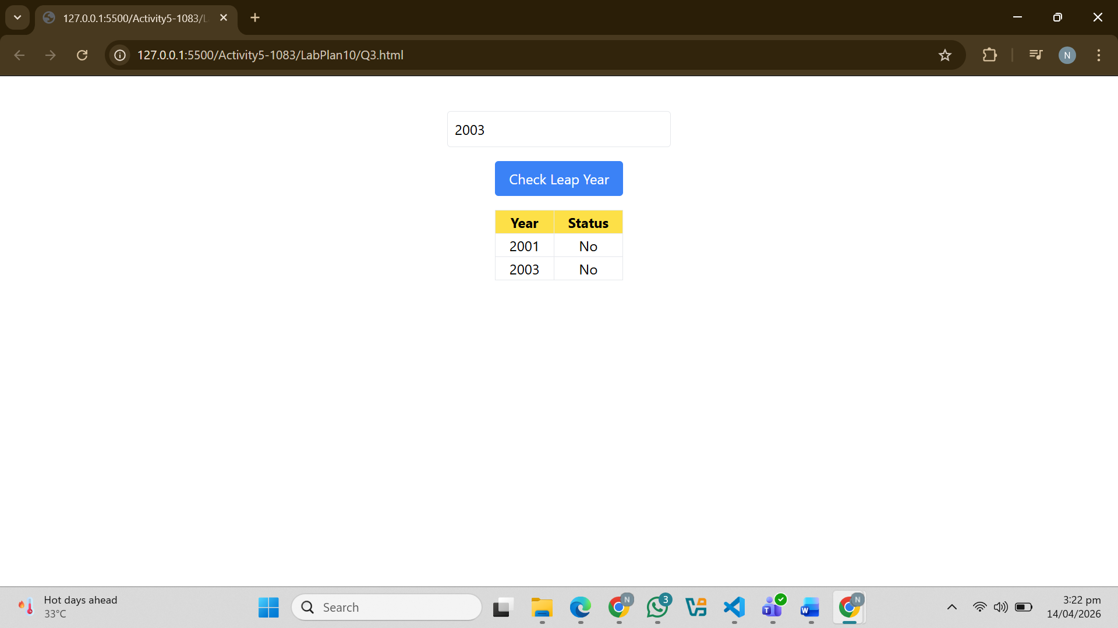
Question. No.4
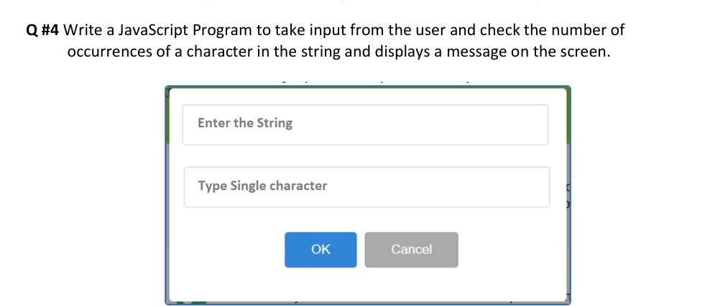
Code:
<!DOCTYPE html>
<html>
<head>
<script src="https://cdn.tailwindcss.com"></script>
</head>

<body class="flex flex-col items-center mt-10">

<input id="text" type="text" placeholder="Enter the string"
class="border p-2 rounded w-64 mb-3">

<input id="char" type="text" placeholder="Type single character"
class="border p-2 rounded w-64 mb-3">

<div class="flex gap-3">

<button onclick="countChar()"
class="bg-blue-500 text-white px-4 py-2 rounded">
OK
</button>

<button onclick="cancelInput()"
class="bg-red-500 text-white px-4 py-2 rounded">
Cancel
</button>

</div>

<script>
function countChar() {
let str = document.getElementById("text").value;
let ch = document.getElementById("char").value;

if (str === "" || ch === "") {
alert("Fields cannot be empty!");
return;
}

if (ch.length !== 1) {
alert("Enter only ONE character");
return;
}

let count = 0;
for (let i = 0; i < str.length; i++) {
if (str[i] === ch) {
count++;
}
}

alert("Occurrences: " + count);
}

function cancelInput() {
document.getElementById("text").value = "";
document.getElementById("char").value = "";
}
</script>

</body>
</html>
Output:
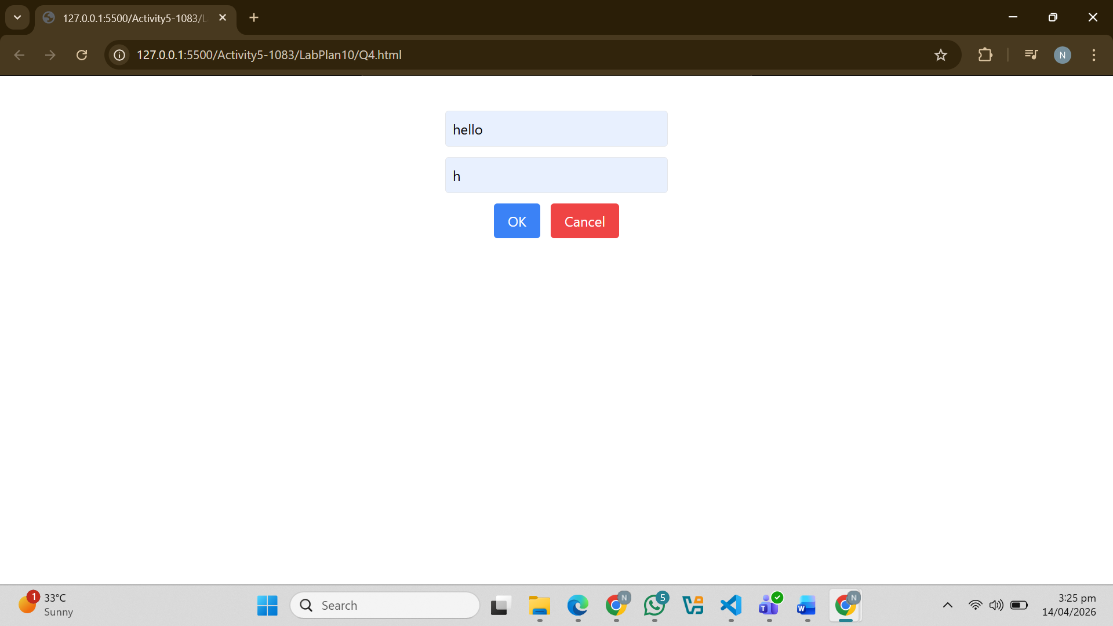
Question. No.5
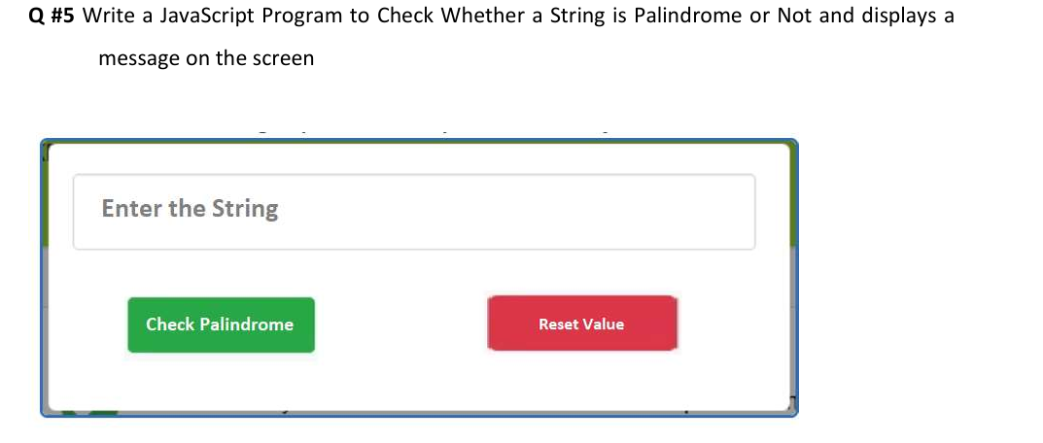
Code:
<!DOCTYPE html>
<html>
<head>
<script src="https://cdn.tailwindcss.com"></script>
</head>

<body class="flex flex-col items-center mt-10">

<input id="text" type="text" placeholder="Enter the String"
class="border p-2 rounded w-64 mb-4">

<div class="flex gap-4">
<button onclick="checkPalindrome()"
class="bg-green-500 text-white px-4 py-2 rounded">
Check Palindrome
</button>

<button onclick="resetValue()"
class="bg-red-500 text-white px-4 py-2 rounded">
Reset Value
</button>
</div>

<script>
function checkPalindrome() {
let str = document.getElementById("text").value;

if (str === "") {
alert("Field cannot be empty!");
return;
}

// Only string check (no numbers)
if (!isNaN(str)) {
alert("Only string values allowed!");
return;
}

let reversed = str.split("").reverse().join("");

if (str === reversed) {
alert("It is a Palindrome");
} else {
alert("Not a Palindrome");
}
}

function resetValue() {
document.getElementById("text").value = "";
}
</script>
</body>
</html>
Output:
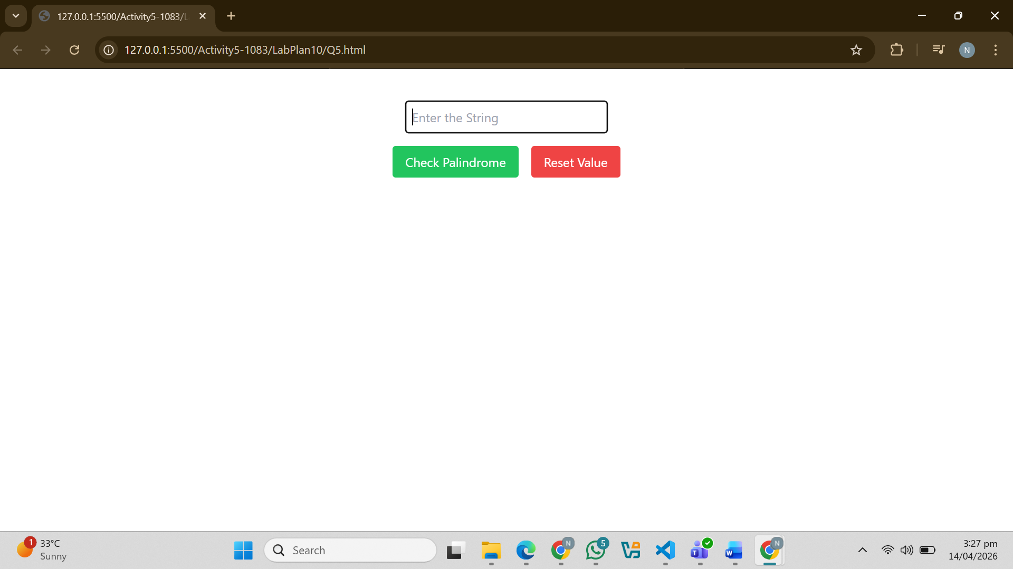
Question.NO.6
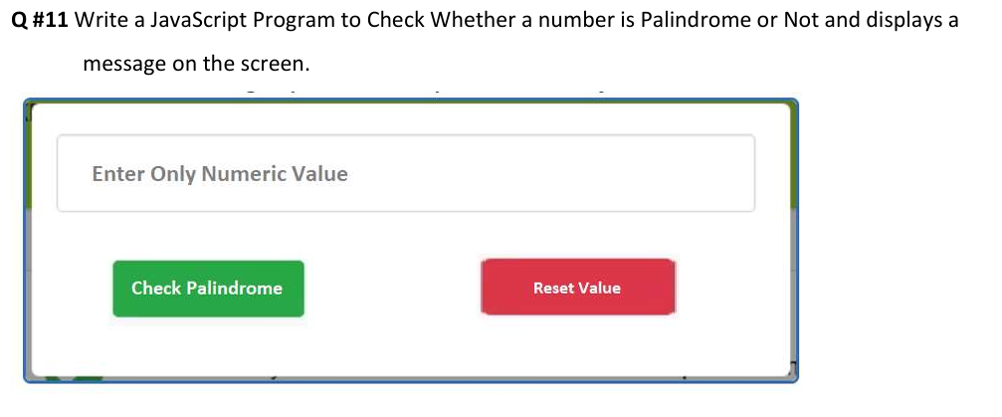
Code:
<!DOCTYPE html>
<html lang="en">
<head>
<meta charset="UTF-8">
<meta name="viewport" content="width=device-width, initial-scale=1.0">
<title>Palindrome Checker</title>
<script src="https://cdn.tailwindcss.com"></script>
</head>
<body class="bg-gray-100 flex items-center justify-center min-h-screen">

<div class="bg-white p-8 rounded-lg shadow-md border border-blue-400 w-full max-w-lg">
<input
type="number"
id="numberInput"
placeholder="Enter Only Numeric Value"
class="w-full p-3 border border-gray-300 rounded mb-6 focus:outline-none focus:ring-2 focus:ring-blue-400"
>

<div class="flex justify-between gap-4">
<button
onclick="checkPalindrome()"
class="bg-green-600 hover:bg-green-700 text-white font-semibold py-2 px-6 rounded transition duration-200 w-1/2">
Check Palindrome
</button>

<button
onclick="resetFields()"
class="bg-red-500 hover:bg-red-600 text-white font-semibold py-2 px-6 rounded transition duration-200 w-1/2">
Reset Value
</button>
</div>

<div id="message" class="mt-6 text-center font-bold text-lg"></div>
</div>

<script>
function checkPalindrome() {
const input = document.getElementById('numberInput');
const messageElement = document.getElementById('message');
const value = input.value;

// 1. Check for empty fields (without using 'required' attribute)
if (value === "") {
messageElement.style.color = "orange";
messageElement.innerText = "Please enter a number first!";
return;
}

// 2. Check for only positive values
const num = parseFloat(value);
if (num < 0) {
messageElement.style.color = "red";
messageElement.innerText = "Please enter a positive value.";
return;
}

// 3. Palindrome Logic
const strValue = value.toString();
const reversedValue = strValue.split('').reverse().join('');

if (strValue === reversedValue) {
messageElement.style.color = "green";
messageElement.innerText = `Yes! ${value} is a Palindrome.`;
} else {
messageElement.style.color = "red";
messageElement.innerText = `No! ${value} is not a Palindrome.`;
}
}

function resetFields() {
document.getElementById('numberInput').value = "";
const messageElement = document.getElementById('message');
messageElement.innerText = "";
}
</script>
</body>
</html>
Output:
